Random Video Chat Platform – Project Requirements Document
Version: 1.1 (Draft) Date: October 17, 2026 Stack: Go microservices, gRPC, event bus, Redis, PostgreSQL, Kubernetes, WebRTC

1. Introduction

1.1 Purpose
This document defines the requirements for a web-based random video and text chat platform in the spirit of Omegle, built as a set of independently deployable microservices. Authenticated users are paired with a random eligible partner, talk over live audio and video (or text only), and can skip to a new partner at any time. The goal is Omegle-style feature parity with a faster, safer and horizontally scalable implementation.

1.2 Scope
In scope (MVP): account registration and login, random one-to-one matchmaking, video chat and text-only chat modes, interest-based matching with a random fallback, WebRTC audio and video, in-session text chat with typing indicators, skip and disconnect, reconnection handling, reporting and blocking, rate limiting and bot protection, moderation tooling, and the microservice platform (API gateway, event bus, observability and autoscaling).
Out of scope for MVP: group rooms, native mobile apps, session recording, monetisation and premium features, and any unmoderated or adult-oriented section.

1.3 Definitions
Term | Meaning
WebRTC | Browser technology for real-time audio, video and data transfer between peers
Signaling | Exchange of connection setup messages (SDP offers and answers, ICE candidates) coordinated by the backend
STUN / TURN | Servers that help peers discover public addresses (STUN) or relay media when a direct connection fails (TURN)
Matchmaking | Server-side logic that pairs two waiting users
Session | A single conversation between two matched users
Microservice | A small, independently deployable service that owns one capability and its own data
API Gateway | Single entry point for REST calls: authentication, routing and rate limiting
Realtime Gateway | Entry point that holds WebSocket connections and routes real-time messages
Event bus | Message backbone that carries facts such as SessionEnded between services
gRPC | Binary request/response protocol used between services
SLO | Service level objective: a measurable performance or availability target

1.4 Key Principle
WebRTC is not the matchmaking system. WebRTC only carries real-time media. The Matchmaking Service decides who is connected to whom, and the Signaling Service coordinates how their browsers connect.

2. Product Overview

2.1 How the Platform Works
- Authentication: the platform verifies the user and their session.
- Random matchmaking: a waiting user is paired with another eligible user.
- Signaling: the backend coordinates the browsers' WebRTC connection setup.
- Live conversation: browsers exchange audio and video peer to peer (or via TURN relay).
- Skip or disconnect: the session ends and the user can search for a new partner.

2.2 Design Choices vs. Standard Approach
Component | Classification
Random one-to-one matching | Core concept shared with Omegle-style products
Text chat and video chat modes | Core Omegle experience
Interest tags with random fallback | Omegle feature
Server-mediated signaling | Standard WebRTC architecture
Browser-based audio and video | Standard WebRTC architecture
Skip and find another person | Core user experience
Microservices behind an API gateway and event bus | Architecture choice
Go services | Technology choice
Redis atomic matchmaking | Implementation choice
PostgreSQL per service for accounts and moderation | Implementation choice
Mandatory authentication | Product choice (the classic experience was anonymous); optional guest mode is behind a feature flag

2.3 Improvements over a Basic Clone
- Race-free matching: a user can never be assigned to two conversations at once.
- Fast skip: the old match is invalidated before a new match can begin.
- Reliable reconnection: temporary network failures never leave users stuck in stale sessions.
- Abuse prevention: reporting, blocking, rate limits and moderation.
- Scalability: independent microservices scale horizontally, and Redis coordinates matching across instances.
- Privacy: minimal data collection and no default video recording.

3. Stakeholders and Users
Role | Description | Key needs
End user | Verified adult who wants to meet new people over video | Quick matching, smooth video, easy skip, feeling of safety
Moderator | Reviews reports and takes action | Report queue, context, ban tools
Administrator | Operates the platform | Monitoring, configuration, user management
Developer / DevOps | Builds and maintains the system | Clear architecture, observability, deployment automation

4. Functional Requirements
Priority: M = Must (MVP), S = Should, C = Could (later phase).

4.1 Authentication and Accounts
ID | Requirement | Priority
FR-AUTH-01 | Users can register with email and password, with email verification | M
FR-AUTH-02 | Users can log in and log out; sessions use short-lived access tokens plus refresh tokens | M
FR-AUTH-03 | Passwords are hashed with a modern adaptive algorithm (Argon2id or bcrypt) | M
FR-AUTH-04 | Users must confirm they are 18 or older at registration and accept Terms and Community Guidelines | M
FR-AUTH-05 | Password reset via emailed one-time link | M
FR-AUTH-06 | Social login (e.g. Google) | C
FR-AUTH-07 | Users can delete their account and associated personal data | M

4.2 Matchmaking
ID | Requirement | Priority
FR-MATCH-01 | An authenticated user can press Start to join the waiting pool | M
FR-MATCH-02 | The Matchmaking Service pairs two waiting users atomically using Redis (Lua script or equivalent atomic operation) | M
FR-MATCH-03 | A user can belong to at most one waiting entry and at most one active session at any time | M
FR-MATCH-04 | Users are never matched with themselves, with users they have blocked, or with users who blocked them | M
FR-MATCH-05 | Recently matched partners are excluded for a configurable cool-down period to avoid immediate rematches | S
FR-MATCH-06 | A user waiting too long sees a status message and may cancel the search | M
FR-MATCH-07 | Banned or suspended users cannot join the pool and are removed from it immediately when suspended | M
FR-MATCH-08 | Users can add up to 5 interest tags; the matcher prefers a partner who shares at least one tag and falls back to pure random matching after a short timeout (default 5 seconds) | M
FR-MATCH-09 | Matched users are shown the interests they have in common | S
FR-MATCH-10 | Chat mode (text or video) is part of the match key, so users only match within the same mode | M
FR-MATCH-11 | Language preference filter; the default is the browser language | S
FR-MATCH-12 | Waiting queues are sharded by mode, language and interest bucket so each queue stays small and fast | M
FR-MATCH-13 | Region preference filter | C

4.3 Signaling and Live Conversation
ID | Requirement | Priority
FR-RTC-01 | The backend exposes a WebSocket signaling channel authenticated with the user's token | M
FR-RTC-02 | The backend relays SDP offers/answers and ICE candidates only between the two users of the same active session | M
FR-RTC-03 | Browsers establish audio and video using WebRTC, with STUN and TURN servers configured | M
FR-RTC-04 | Users can mute/unmute the microphone and enable/disable the camera during a session | M
FR-RTC-05 | Users can exchange text messages during a session over the signaling channel or a WebRTC data channel | M
FR-RTC-06 | Media quality adapts to network conditions; the UI shows connection state (connecting, connected, poor connection, disconnected) | M
FR-RTC-07 | Camera and microphone permissions are requested with clear explanations, and errors are handled gracefully | M

4.4 Skip, Disconnect and Reconnection
ID | Requirement | Priority
FR-SESS-01 | A Skip button ends the current session and immediately starts a new search | M
FR-SESS-02 | On skip, the old session is invalidated server-side before the user re-enters the pool; late signaling messages for the old session are rejected | M
FR-SESS-03 | The partner is notified immediately when the other user skips or disconnects, and is offered to find a new match | M
FR-SESS-04 | If a client loses its connection, the server holds the session for a short grace period (default 10–15 seconds) to allow reconnect | M
FR-SESS-05 | If the grace period expires, the session is ended, the partner is notified, and all session state is cleaned up | M
FR-SESS-06 | A heartbeat mechanism detects dead connections so stale sessions and stale waiting entries are removed automatically | M
FR-SESS-07 | If direct peer connection fails, the client attempts ICE restart or TURN relay before declaring failure | S

4.5 Safety, Reporting and Moderation
ID | Requirement | Priority
FR-SAFE-01 | Users can report their current or most recent partner with a reason category and optional comment | M
FR-SAFE-02 | Users can block a partner so they are never matched again | M
FR-SAFE-03 | Rate limits apply to registration, login, matching requests, skip frequency and reports | M
FR-SAFE-04 | Moderators have a dashboard with a report queue, user history and actions (warn, suspend, ban) | M
FR-SAFE-05 | Repeat offenders are escalated automatically (for example temporary suspension after a threshold of validated reports) | S
FR-SAFE-06 | When a report is submitted, a short rolling evidence snapshot (such as recent text messages and session metadata) may be preserved for review, disclosed in the privacy policy | S
FR-SAFE-07 | Automated screening for nudity or other prohibited content on video frames, performed in a privacy-conscious way | C
FR-SAFE-08 | A documented process for handling and escalating illegal content, including child safety, to the relevant authorities as required by law | M
FR-SAFE-09 | Age assurance beyond self-declaration (for example ID or third-party age verification) evaluated before launch based on target markets and regulation | S
FR-SAFE-10 | Users can appeal moderation decisions | S

4.6 Administration
ID | Requirement | Priority
FR-ADM-01 | Administrators can view live metrics (online users, queue size, active sessions, average wait time) | S
FR-ADM-02 | Administrators can manage moderator accounts and roles | M
FR-ADM-03 | Configuration values (cool-downs, rate limits, grace periods) can be adjusted without redeploying | S

4.7 Omegle-Style Experience and Chat Modes
The platform reproduces the familiar Omegle experience feature by feature; the table lists each one and how it is delivered.
ID | Feature | Requirement | Priority
FR-OME-01 | Text chat mode | Text-only chat with a random partner, with no camera or microphone needed | M
FR-OME-02 | Video chat mode | Video with text chat beside it, as in classic Omegle | M
FR-OME-03 | Interests | Optional interest tags before starting; shared tags are highlighted on match (see FR-MATCH-08 and FR-MATCH-09) | M
FR-OME-04 | Anonymous partner | Partners appear only as "Stranger" and "You"; no username, email or profile data is ever shown | M
FR-OME-05 | System messages | Familiar status lines: looking for someone to chat with, you are now chatting with a random stranger, stranger has disconnected | M
FR-OME-06 | Typing indicator | "Stranger is typing..." shown in real time and rate-limited | M
FR-OME-07 | Two-step disconnect | Skip button and Esc key; a second press confirms, to prevent accidental skips (configurable) | S
FR-OME-08 | New chat | One click starts a new search; the ended chat stays readable until the new search starts | M
FR-OME-09 | Online counter | Approximate count of users currently online | S
FR-OME-10 | Chat transcript | Users can save their own chat text locally; the server does not store message content | S
FR-OME-11 | Video controls | Mute, camera off, full screen, mirrored self-view and swap of local and remote picture | S
FR-OME-12 | Safety banner | Persistent notice not to share personal information, with a one-click report button | M
FR-OME-13 | Bot protection | CAPTCHA or proof-of-work challenge on suspicious behaviour; links from new accounts are blocked | M
FR-OME-14 | Guest mode | Optional anonymous entry without an account, text-only, with CAPTCHA and stricter limits; feature flag, off by default | C
FR-OME-15 | College mode | Match only users with a verified student email domain | C
FR-OME-16 | Question mode | One user asks a question and two others discuss it while the asker watches | C
FR-OME-01 raises FR-RTC-05 (text chat during a session) to a Must.
Deliberately not replicated: the unmoderated section and any adult-oriented mode of the original service. Every session follows the same moderation, reporting and 18+ rules. The original service closed in 2023 amid litigation over misuse, which is why safety is a core feature here.

5. Non-Functional Requirements

5.1 Performance
- NFR-PERF-01: Matching latency under 500 ms at the 95th percentile (under 1 second at the 99th) when an eligible partner is waiting.
- NFR-PERF-02: Signaling message relay under 100 ms at the 95th percentile and under 250 ms at the 99th, within a region.
- NFR-PERF-03: Time from match to first video frame under 3 seconds for 90 percent of direct connections and under 5 seconds for relayed ones.
- NFR-PERF-04: Skip processed server-side in under 300 ms at the 95th percentile; the interface reacts instantly and shows the new search without waiting for the server.
- NFR-PERF-05: API Gateway adds under 10 ms at the 95th percentile; other REST calls complete in under 200 ms at the 95th percentile.
- NFR-PERF-06: Chat page loads in under 2 seconds on a 4G connection, with a script bundle under 250 KB compressed, code splitting and lazy loading of moderation and settings screens.
- NFR-PERF-07: Each Realtime Gateway instance sustains at least 20,000 concurrent WebSocket connections (target, confirmed by load test).
- NFR-PERF-08: Video targets 720p at 30 fps and adapts down to 240p on weak networks, with a default cap of 1.5 Mbps per direction.
- NFR-PERF-09: The match-and-signal hot path makes no PostgreSQL call and never waits on moderation, analytics or email.

5.2 Scalability
- NFR-SCALE-01: Every service is stateless; shared state lives in Redis, PostgreSQL and the event bus. Services scale independently using autoscaling on CPU, active connections and queue depth.
- NFR-SCALE-02: Realtime Gateway instances can be added at any time; a message for a user on another instance is routed through Redis or the event bus by session ID.
- NFR-SCALE-03: Initial target of 5,000 concurrent users, with an architecture that reaches 100,000 or more by adding nodes, without redesign.
- NFR-SCALE-04: Waiting queues are sharded by mode, language and interest bucket across a Redis Cluster, so there is no global lock or single hot key.
- NFR-SCALE-05: TURN capacity is sized for the share of sessions that cannot connect directly (commonly 10 to 20 percent), since relayed media is bandwidth-heavy.
- NFR-SCALE-06: The deployment is multi-region ready: users are routed to the nearest region, and matching runs per region in the MVP.

5.3 Reliability and Availability
- NFR-REL-01: Target availability of 99.5 percent for the MVP.
- NFR-REL-02: Graceful degradation: if Redis is unavailable, new matching stops with a clear message and no corrupted sessions are created.
- NFR-REL-03: All session-ending paths (skip, disconnect, timeout, crash) result in consistent cleanup with no orphaned state.

5.4 Security
- NFR-SEC-01: All traffic uses TLS; WebSockets use WSS; WebRTC media is encrypted by default (DTLS-SRTP).
- NFR-SEC-02: Time-limited TURN credentials are issued per session; static TURN credentials are never exposed to clients.
- NFR-SEC-03: Input validation, CORS and CSRF protection, and secure HTTP headers on all endpoints.
- NFR-SEC-04: Peer IP exposure is considered: users are informed that direct WebRTC connections can reveal IP addresses, and a TURN-relay-only option is evaluated to protect privacy.
- NFR-SEC-05: Secrets are stored in a secrets manager, never in source control.
- NFR-SEC-06: Regular dependency scanning and a documented vulnerability response process.
- NFR-SEC-07: Service-to-service traffic uses mutual TLS, and network policies allow only the calls listed in the service catalogue.
- NFR-SEC-08: The gateway validates the user token once; internal services receive a signed identity context and check authorization for their own data.

5.5 Privacy and Compliance
- NFR-PRIV-01: No audio or video recording by default.
- NFR-PRIV-02: Data minimisation: collect only what is needed for authentication, safety and operations.
- NFR-PRIV-03: Defined retention periods for logs, reports and evidence; automatic deletion afterward.
- NFR-PRIV-04: Privacy policy, Terms of Service and Community Guidelines published and accepted before first use.
- NFR-PRIV-05: Support for data access and deletion requests in line with applicable laws (such as GDPR and India's DPDP Act) in the markets served.

5.6 Usability and Compatibility
- NFR-USE-01: Works on current versions of Chrome, Edge, Firefox and Safari, on desktop and mobile browsers.
- NFR-USE-02: Responsive layout; a single prominent action for Start and Skip.
- NFR-USE-03: Accessible UI following WCAG 2.1 AA where practical (keyboard navigation, contrast, captions for text chat).

5.7 Observability and Maintainability
- NFR-OBS-01: Structured logging, metrics (Prometheus-compatible) and distributed tracing.
- NFR-OBS-02: Alerts on queue growth, match failure rate, signaling errors and TURN saturation.
- NFR-MNT-01: Automated unit, integration and load tests with CI/CD deployment pipeline.

5.8 Performance Engineering
The performance targets above are met by keeping the real-time path short and by isolating everything slow from it.
Area | Technique | Benefit
Matchmaking | One atomic Redis script per join, sharded queues, block lists cached in Redis | One round trip per pairing, no cross-queue contention
Signaling | Small JSON messages, relay by session ID, membership checked against a cached session record | Low relay latency without database reads
Hot path | Token verified at the gateway; no PostgreSQL, moderation or analytics call between Start and first frame | Latency independent of slow services
Media | Peer-to-peer first, regional coturn nodes as fallback, ICE trickle, TURN over TLS on port 443 as last resort | Fast connects and fewer failures behind strict firewalls
Client | Camera permission and signaling socket prepared on page load, credentials prefetched, optimistic skip | Faster perceived match
Network | HTTP/2 or HTTP/3 at the edge, CDN for static files, Brotli compression | Fast first load
Go runtime | Bounded per-connection buffers, write deadlines, backpressure, object reuse on hot paths, profiling in staging | Stable memory and latency under load
Database | Connection pooling, indexed lookups, read replicas for moderator screens, logs written asynchronously from events | Database never blocks chat
Load control | Autoscaling before peak hours; when overloaded, new searches get a busy message while active sessions are protected | Graceful behaviour at saturation
Capacity example: 5,000 concurrent users form 2,500 sessions. If 20 percent are relayed at 1.5 Mbps per direction, each relayed session sends 3 Mbps through TURN, so egress is about 500 x 3 = 1.5 Gbps.

6. Microservice Architecture

6.1 Principles
The platform is split into small services that each own one capability and one data store, talk through gRPC for requests and an event bus for facts, and sit behind two gateways.
- Single responsibility: one service per domain (identity, matchmaking, sessions, signaling, safety and so on).
- Database per service: no shared tables; other services use an API or events and refer to users by ID only.
- Stateless services: state lives in Redis, PostgreSQL and the event bus, so any instance can serve any request.
- Synchronous for commands, asynchronous for facts: gRPC for "create this session"; events such as SessionEnded for "this happened".
- Hot path isolation: matching and signaling never wait on moderation, analytics or email.
- Failure isolation: timeouts, retries with backoff, circuit breakers and bulkheads, so a failing support service cannot stop chat.
- Independent delivery: each service has its own container image, pipeline and versioned contract.
- Observable and secure by default: tracing with correlation IDs, metrics on every service, mutual TLS between services.

6.2 System Architecture
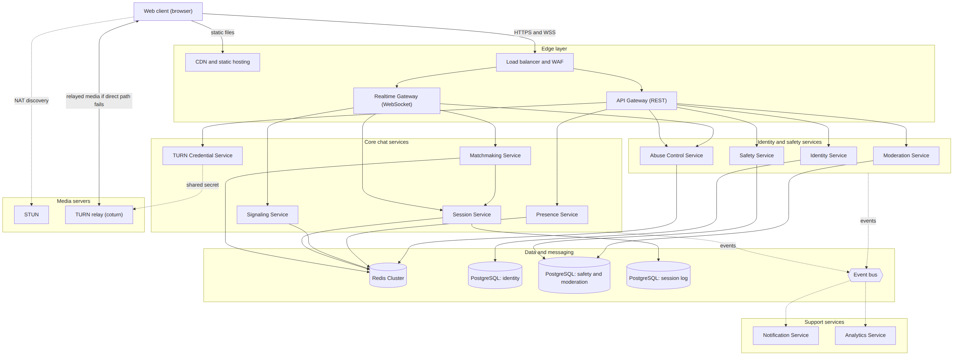
Clients reach the system through two entry points: the API Gateway for request and response calls and the Realtime Gateway for WebSocket traffic. Every other service stays on the private network, and only the Matchmaking, Session and Signaling services sit on the live chat path.

6.3 Microservice Catalogue
Thirteen services, each with one owner of its data. The MVP ships ten of them; Abuse Control, Presence and Analytics follow in Phase 2 (section 11).
Service | Responsibility | Data store | Events published | Events consumed
API Gateway | TLS, token validation, routing, request rate limits, request IDs | None | None | None
Realtime Gateway | Holds WebSocket connections, heartbeats and backpressure; routes client messages to services and pushes server events to clients | Redis (connection routing) | UserDisconnected, UserReconnected | MatchCreated, SessionEnded
Identity Service | Registration, login, tokens, email verification, password reset, 18+ confirmation, account deletion | PostgreSQL (identity) | UserRegistered, UserDeleted | UserSuspended, UserBanned
Matchmaking Service | Queues, atomic pairing, filters for mode, language, interests, blocks and cool-down | Redis (queues, cool-down) | MatchCreated | UserSuspended, BlockAdded
Session Service | Session state machine, one-session-per-user rule, reconnect grace period, cleanup, session metadata log | Redis (active), PostgreSQL (session log) | SessionStarted, SessionEnded | UserDisconnected, UserReconnected
Signaling Service | Relays offers, answers, ICE candidates, chat messages and typing events between the two users of one session | Redis (session cache) | None | SessionEnded
TURN Credential Service | Issues short-lived STUN and TURN credentials per session | None | None | None
Safety Service | Reports, blocks, short evidence snapshots on report | PostgreSQL (safety) | ReportFiled, BlockAdded | SessionEnded
Moderation Service | Report queue, decisions, suspensions, bans, appeals, moderator and admin tools | PostgreSQL (safety) | UserSuspended, UserBanned | ReportFiled, RiskFlagged
Notification Service | Email for verification, password reset and moderation notices | None (provider queue) | None | UserRegistered, UserSuspended, UserBanned
Abuse Control Service | Rate limits, bot detection, CAPTCHA challenges, risk scoring | Redis | RiskFlagged | SessionEnded, ReportFiled
Presence Service | Online user count and heartbeat aggregation | Redis | None | UserDisconnected, UserReconnected
Analytics Service | Turns events into metrics and dashboards; stores no message or media content | Time-series store | None | All events

6.4 Matchmaking Flow
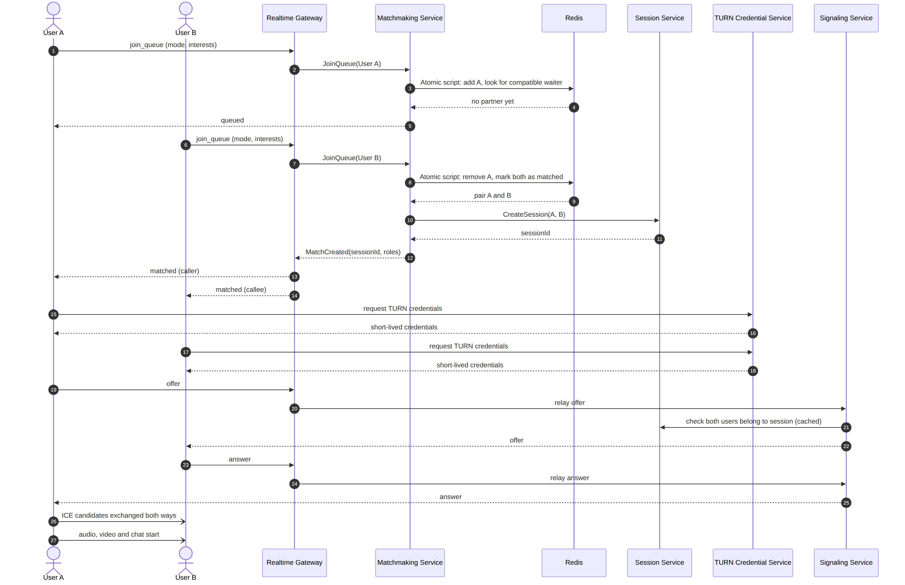
The atomic Redis script is the only place a pairing is decided, so two Matchmaking instances can never assign the same user twice. If no interest match is found within the timeout, the same script falls back to random pairing.

6.5 Session Lifecycle and Skip
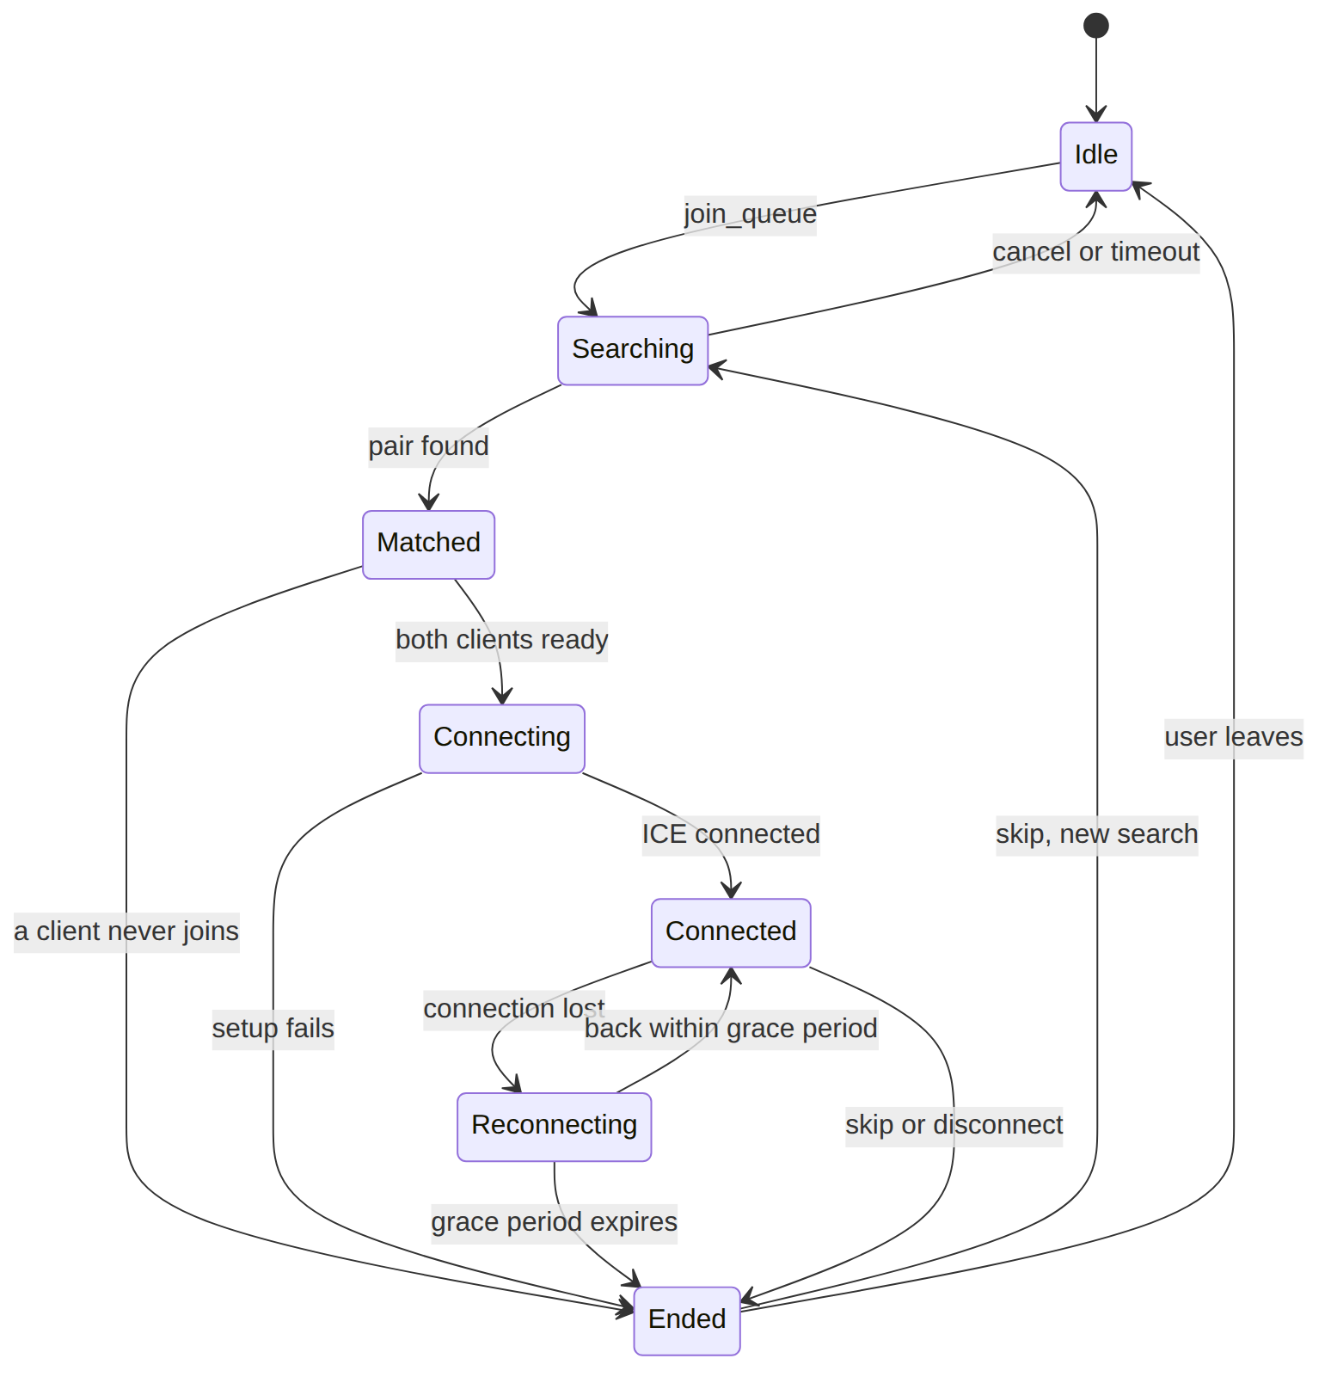
Only the Session Service changes state. Every transition is validated server-side, so signaling for an ended session is rejected.
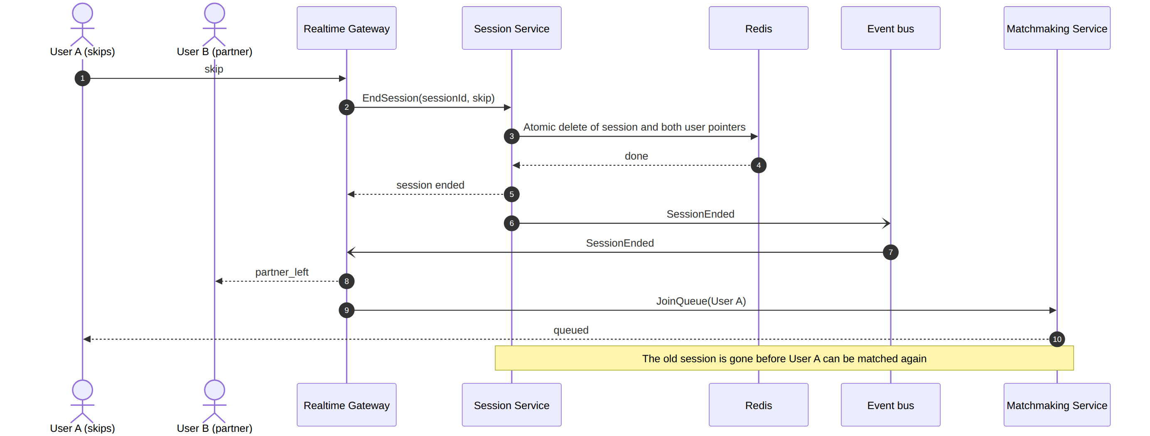
This ordering is what makes Skip fast and safe: the old match is invalidated first, and late messages for it are rejected.

6.6 WebRTC Media Path
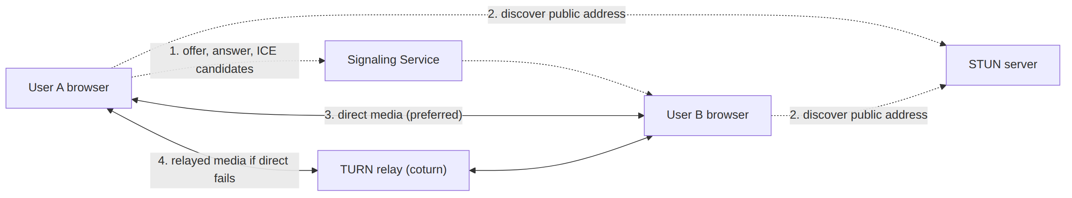
Media never passes through the application services. The backend only brokers the connection; if the browsers cannot reach each other directly, regional TURN nodes relay the encrypted media.

6.7 Data Architecture
Each service owns its store. References between services use user IDs only; no foreign key crosses a service boundary.
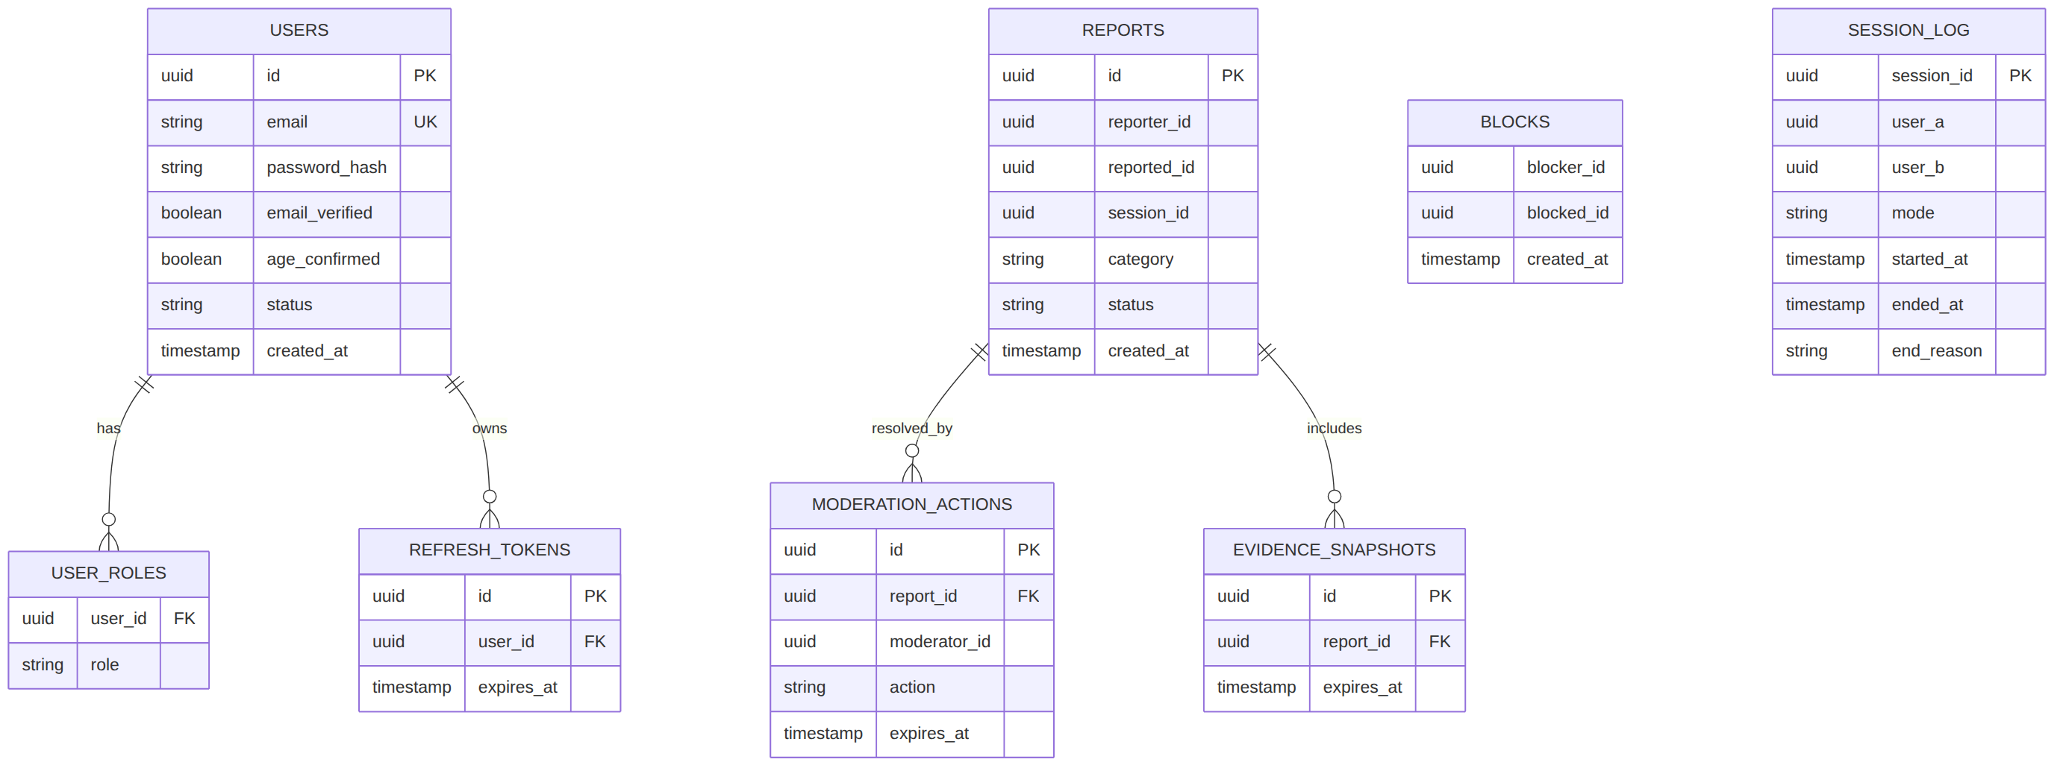
USERS, USER_ROLES and REFRESH_TOKENS belong to the Identity Service; BLOCKS, REPORTS, EVIDENCE_SNAPSHOTS and MODERATION_ACTIONS to the Safety and Moderation services; SESSION_LOG to the Session Service (metadata only, no media or message content).
Redis key pattern | Owner | Purpose
queue:{mode}:{language}:{bucket} | Matchmaking | Sorted set of users waiting in one shard
user:{id}:state | Matchmaking, Session | Current state (idle, searching, in session) with TTL
session:{id} | Session | Participants, status and timestamps
user:{id}:session | Session | Pointer to the user's current session; enforces one session per user
presence:{id} | Realtime Gateway | Heartbeat key with TTL for stale detection
recent:{id} | Matchmaking | Recently matched partners for cool-down
blocks:{id} | Matchmaking | Cached block list for fast filtering
ratelimit:{scope}:{id} | Gateways, Abuse Control | Counters for rate limiting

6.8 Event Catalogue
Events are facts published on the bus. Delivery is at-least-once, so every consumer is idempotent.
Event | Published by | Consumed by | Purpose
UserRegistered | Identity | Notification, Analytics | Send the verification email, count signups
UserDeleted | Identity | Safety, Session, Analytics | Remove or anonymise the user's data elsewhere
UserSuspended, UserBanned | Moderation | Identity, Matchmaking, Notification | Block login and matching, notify the user
MatchCreated | Matchmaking | Realtime Gateway, Analytics | Tell both clients to start connecting
SessionStarted | Session | Analytics | Track live sessions and wait times
SessionEnded | Session | Realtime Gateway, Signaling, Safety, Abuse Control, Analytics | Notify the partner, clean caches, keep the last-partner reference for reporting
UserDisconnected, UserReconnected | Realtime Gateway | Session, Presence | Start or cancel the reconnect grace period
ReportFiled | Safety | Moderation, Abuse Control | Queue the report and update risk scores
BlockAdded | Safety | Matchmaking | Update cached block lists
RiskFlagged | Abuse Control | Moderation | Escalate suspicious accounts for review

6.9 Deployment Architecture
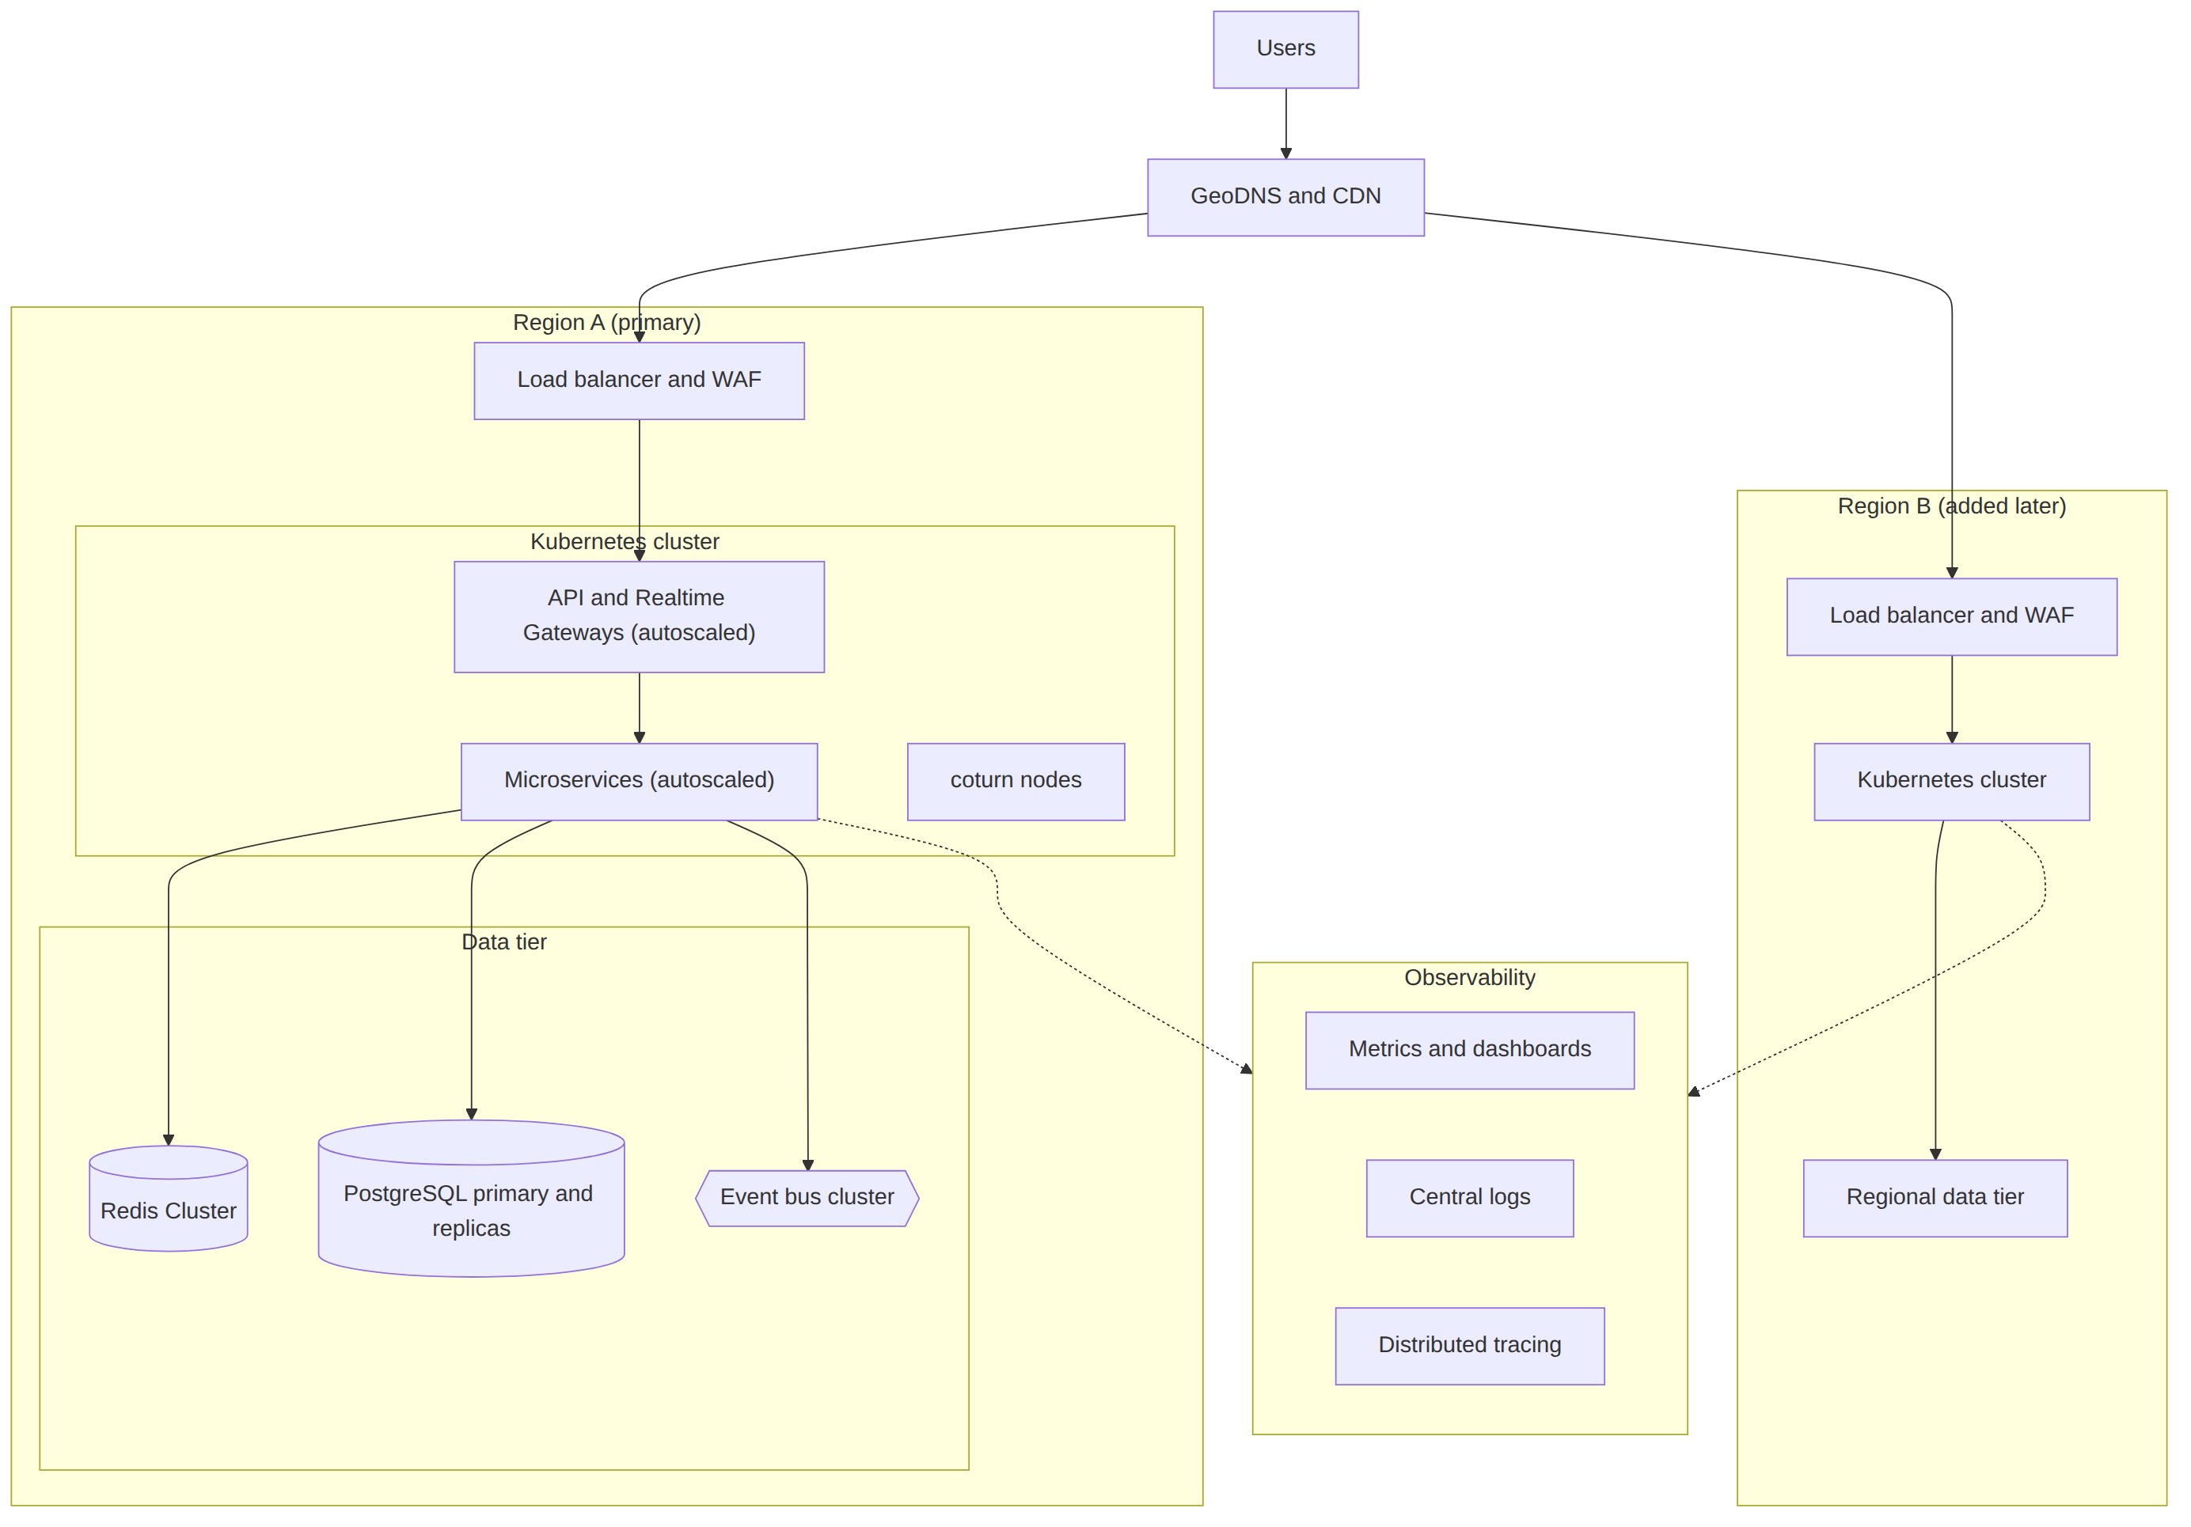
Each region is self-contained for matching in the MVP: a user is routed to the nearest region and matched there. Stateless services autoscale on CPU, connections and queue depth, while the data tier scales by adding shards and replicas.

6.10 Resilience and Technology Stack
Pattern | Where it applies
Timeouts and deadlines on every call | All gRPC and HTTP calls between services
Retries with exponential backoff and jitter | Idempotent calls only
Circuit breakers and bulkheads | Calls to Safety, Moderation and Notification, so they cannot slow chat
Outbox pattern | Services that update their database and publish an event in one step
Idempotent consumers and dead-letter queues | Every event subscriber
Health and readiness probes, graceful shutdown | All pods; connections drain before a Realtime Gateway stops
Load shedding | Gateways return a busy message instead of accepting work they cannot finish
Degraded modes | Redis outage stops new matching with a clear message; active calls continue because media is peer-to-peer

Layer | Technology
Services | Go, gRPC with Protobuf contracts, REST and WebSocket at the edge
Event bus | NATS JetStream proposed; Kafka is the alternative (see open questions)
Data | Redis Cluster, PostgreSQL per service with migrations, PgBouncer for pooling
Media | Browser WebRTC, coturn for STUN and TURN
Platform | Docker, Kubernetes with autoscaling, service mesh or equivalent for mutual TLS
Observability | OpenTelemetry tracing, Prometheus metrics, Grafana dashboards, structured central logs
Frontend | React, Vue or Svelte with the browser WebRTC API

7. API Overview

7.1 REST Endpoints (indicative)
Method | Path | Service | Purpose
POST | /api/auth/register | Identity | Create account
POST | /api/auth/login | Identity | Obtain tokens
POST | /api/auth/refresh | Identity | Refresh access token
POST | /api/auth/logout | Identity | Invalidate session
GET | /api/me | Identity | Current user profile
DELETE | /api/me | Identity | Delete account
GET | /api/turn-credentials | TURN Credential | Short-lived STUN and TURN credentials for a session
GET | /api/stats/online | Presence | Approximate online user count
POST | /api/reports | Safety | Submit a report
POST | /api/blocks | Safety | Block a user
GET | /api/admin/reports | Moderation | Moderator report queue
POST | /api/admin/users/{id}/action | Moderation | Suspend or ban a user

7.2 WebSocket Events (indicative)
Event | Direction | Handled by | Purpose
join_queue (mode, interests, language) | Client to server | Matchmaking | Start searching
leave_queue | Client to server | Matchmaking | Cancel the search
skip | Client to server | Session | End the session and start a new search
offer, answer, ice_candidate | Both | Signaling | WebRTC connection setup
chat_message, typing_start, typing_stop | Both | Signaling | Text chat and typing indicator
heartbeat | Client to server | Realtime Gateway | Keep the connection and session alive
queued, matched (sessionId, role, shared interests) | Server to client | Matchmaking | Search status and match result
partner_left, session_ended | Server to client | Session | Partner skipped or disconnected
error, busy | Server to client | Any service | Failure or overload notice

7.3 Internal Contracts
- gRPC: services call each other with Protobuf contracts, a deadline on every call, standard error codes and backward-compatible changes only (add fields, never repurpose them).
- Events: every event carries an ID, type, version, timestamp and correlation ID; consumers ignore unknown fields and handle duplicates safely.
- Contract tests: each service publishes its contract, and consumers test against it in CI before release.
- Versioning: breaking changes ship as a new version running alongside the old one until all consumers have moved.

8. Constraints, Assumptions and Dependencies

8.1 Constraints
- Browser-only delivery for the MVP.
- Go, Redis and PostgreSQL are fixed technology choices; services run as containers on Kubernetes.
- Services communicate over gRPC and an event bus; the bus product (NATS JetStream proposed) is to be confirmed.
- Peer-to-peer media means some users behind restrictive NATs require TURN relay, which adds infrastructure cost.
- A microservice setup needs more tooling (CI/CD, tracing, service discovery) than a single application, so a small platform team is assumed.

8.2 Assumptions
- Users have a working camera, microphone and a reasonably stable internet connection.
- Launch markets and their legal requirements (age assurance, content moderation, data protection) will be confirmed before public release.

8.3 Dependencies
- Email delivery provider for verification and password reset.
- STUN/TURN infrastructure with sufficient bandwidth.
- Hosting with WebSocket and UDP support.
- Moderation staffing or a trust-and-safety partner.

9. Risks and Mitigations
Risk | Impact | Mitigation
Abuse and inappropriate content, including risks to minors | Severe legal and reputational harm | 18+ gating, reporting and blocking, moderation team, escalation process, automated screening, age assurance review
Distributed complexity: more moving parts and harder debugging | Slower delivery and cascading failures | Tracing with correlation IDs, contract tests, circuit breakers, clear service ownership; ship the ten MVP services first and split further only when metrics justify it
Latency added by service hops | Misses the performance targets | Keep the hot path to three services, use gRPC, co-locate services, enforce latency budgets in load tests
Event bus outage or lost events | Stale moderation or notification state | Clustered persistent streams, dead-letter queues, idempotent consumers; chat never depends on the bus to function
Inconsistent data across services | Wrong ban or block state | Outbox pattern, idempotent handlers, periodic reconciliation jobs
TURN bandwidth costs grow faster than expected | Budget overrun | Monitor relay ratio, autoscale TURN, set per-session bitrate caps
Race conditions in matching | Users in two sessions or ghost sessions | Atomic Redis scripts, single-session pointer, thorough concurrency tests
Stale sessions after network drops | Users stuck, poor experience | Heartbeats, TTLs, grace period and guaranteed cleanup paths
Regulatory change | Rework or market exit | Legal review before launch, configurable compliance features
Low user density at launch causes long waits | Poor retention | Staged launch, queue messaging, interest tags with random fallback
Peer IP exposure | Privacy complaints | User disclosure and optional relay-only mode

10. Testing and Acceptance Criteria

10.1 Test Strategy
- Unit tests for matching logic, state machine and rate limiters.
- Concurrency tests simulating thousands of simultaneous join and skip actions to prove no user is double-assigned.
- Contract tests between every pair of services that call each other or share events.
- Integration tests for authentication, signaling relay and session cleanup.
- Network tests with simulated packet loss, latency, disconnects and NAT types.
- Load tests to 5,000 concurrent users and beyond, with the NFR-PERF targets enforced as pass or fail gates in CI.
- Chaos tests that kill service pods, a Redis node and the event bus, and confirm active sessions survive and services recover.
- Security tests including authorization checks on signaling and a penetration test before launch.
- Cross-browser tests on supported browsers and devices.

10.2 MVP Acceptance Criteria
- A verified adult user can log in, choose text or video mode, press Start and be connected to another waiting user.
- Interest tags match users who share one, and fall back to random matching within the timeout.
- Under concurrent load tests, no user is ever in more than one active session.
- Pressing Skip ends the current session for both users and begins a new search within 2 seconds.
- A temporary network drop shorter than the grace period restores the session; a longer drop ends it cleanly for both sides.
- Blocked users are never matched with each other.
- Reports reach the moderation queue and a moderator can suspend or ban the reported user, taking effect immediately.
- No media is recorded or stored by default, and the server does not keep chat message content.
- At 5,000 concurrent users the load test meets the NFR-PERF targets (matching under 500 ms at the 95th percentile).
- Stopping any single service instance does not end active calls, and signaling and matching recover automatically.
- All traffic is encrypted, service-to-service calls use mutual TLS, and rate limits are enforced.

11. Roadmap
Phase | Deliverables
Phase 0: Foundations | Detailed design, Protobuf and event contracts, legal and compliance review, Kubernetes platform, CI/CD, observability stack
Phase 1: MVP | API Gateway, Realtime Gateway, Identity, Matchmaking, Session, Signaling, TURN Credential, Safety, Moderation and Notification services; text and video chat, interest matching, skip, reconnection, reporting and blocking
Phase 2: Hardening | Abuse Control, Presence and Analytics services, load and chaos testing against the SLOs, autoscaling tuning, closed beta
Phase 3: Public launch | Age assurance upgrade, automated moderation, appeals, multi-region readiness, performance tuning
Phase 4: Growth | Language and region filters, college mode, question mode, social login, guest mode if approved, native mobile apps

12. Open Questions
- Which launch countries, and what age assurance level do they require?
- Will the platform use a managed TURN service or self-hosted coturn?
- Who staffs moderation, and what are the target response times for reports?
- Event bus: NATS JetStream or Kafka?
- Managed Kubernetes or self-operated, and on which cloud?
- Should the optional guest mode (anonymous, text-only) ever be offered, given the mandatory-authentication choice?
- What are the retention periods for reports and evidence snapshots?
- When should a second region be added?

13. Recommendation Summary
Build the classic Omegle-style experience first, as a small set of focused microservices: start with the ten MVP services, keep the live chat path to three of them, and split further only when load or team size demands it. Use Go, Redis, PostgreSQL and an event bus to make matching race-free, fast and scalable. Treat safety, moderation, privacy and performance targets as core features from day one rather than add-ons.

